Lin Hong (洪琳)
Central Oregon Community College
2018
BEGINNING CHINESE
初级汉语课本

Pre-Unit 2

LEARNING OBJECTIVES

Once I have mastered this unit, I will：
- understand the four tones and neutral tone and their tone marks;
- be able to identify the tones and pronounce the rehearsed words using the appropriate tone;
- understand the basic concepts of the Mandarin writing system: strokes, radicals and phonetic components, and character composition;
- be able to identify strokes and composition, and to trace characters using appropriate stroke order;
- have memorized some survival expressions; and
- have a basic overview of the Chinese language, including formation of Chinese characters, grammar features, and vocabulary.

Mandarin Phonology (Sound System) II
Neutral Tone
In addition to the four tones, there is also a neutral tone in Mandarin. There is no tone mark for neutral tone syllables. The neutral tone syllable is pronounced briefly and the pitch value is determined by the stressed preceding syllable.
1st tone 2nd tone 3rd tone 4th tone
Following a 1st tone, a neutral tone carries a pitch value of 2, māma;
Following a 2nd tone, a neutral tone carries a pitch value of 3, bóbo;
Following a 3rd tone, a neutral tone carries a pitch value of 4, lǐzi;
Following a 4th tone, a neutral tone carries a pitch value of 1, kuàizi.

Tone Sandhi (Tone Changes)
3rd tone + 3rd tone 2nd tone + 3rd tone fǔdǎo – fúdǎo

Chinese Writing System
Basic Strokes
A basic stroke is a single calligraphic mark moving in one direction across a writing surface. Here are some basic strokes，
Strokes | Pinyin | English | Example
 | diǎn | dot | 主
 | héng | horizontal | 二
 | shù | vertical | 中
 | piē | downward left | 千
 | nà | downward right | 人
 | tí | upward | 江
 | héng gōu | horizontal hook | 字
 | shù gōu | vertical hook | 小
 | xié gōu | slanted hook | 我
 | héng zhé | horizontal bend | 口
 | shù zhé | vertical bend | 山

Radicals
The word “radical” in Chinese 部首 (bùshǒu) literally means "section header." Traditionally Chinese characters are grouped according to their radicals in a Chinese dictionary. These radicals are often also semantic indicators that tell the meanings of the characters. Even though in some cases the original semantic connection has become obscure over time, it is a very efficient way to learn characters if you learn a good amount of basic radicals.
Here is:
A View of Radicals
(https://www.gotcharacters.com/wp/a-radical-view/)
Phonetic Components
A phonetic component gives the pronunciation of a Chinese character. Almost 80% of modern Chinese characters are pictophonetic characters, with one semantic indicator (radical) and one phonetic component. For instance, the phonetic component 青 (qīng) indicates the pronunciations of 请（qǐng）/晴（qíng）/清（qīng）/情（qíng）. Usually the right side of a pictophonetic character is the phonetic component, and the left side is the semantic indicator (radical).
Character Composition
There are 9 kinds of common compositions of characters. By knowing the composition of characters, you will find it becomes easier to memorize characters by some components than by individual strokes. There are some less common compositions that are not included here. The common ones are as follows:
口 人 几 大 白 我
你 好 张 叔 阿 妈
怎 字 安 杰 多 爸
问 同 风 间 周

回 国 因
班 搬 街
喜 曼 鼻
这 过 起 道
病 床 麻

Stroke Order
Following the stroke order rules will make it easier for you to memorize characters and identify similar characters. Your handwriting will also look better if you write characters in the correct stroke order.
From left to right | 人：
From top to bottom | 上：
Horizontal before vertical | 十：
From outside to inside | 问：
Middle before two sides | 小：
Inside before closing | 日：

Survival Expressions and Numbers
1.
Sorry! | Duìbùqǐ!
Excuse me. May I ask… | Qǐngwèn….?
Thank you. | Xièxiè.
What is this? | Zhè shì shénme?
I don’t know. | Wǒ bù zhīdào.
I don’t understand. | Wǒ bù dǒng.
How do you say…in Chinese? | …zhōngwén zěnme shuō?
What does…mean? | …shì shénme yìsi?
I am an American. | Wǒ shì měiguó rén.

2.
0 | 1 | 2 | 3 | 4 | 5 | 6 | 7 | 8 | 9 | 10
〇 | 一 | 二 | 三 | 四 | 五 | 六 | 七 | 八 | 九 | 十
líng | yī | èr | sān | sì | wǔ | liù | qī | bā | jiǔ | shí

Overview of the Chinese Language II
Formation of Chinese Characters
A common claim that Chinese writing is pictographic and each character represents a picture is not really true. Only a small amount of ancient characters evolved from pictures. The majority of modern Chinese characters are pictophonetic characters consisting of a semantic radical and a phonetic component.
Chinese characters can be divided into six categories based on the manner in which they are formed or derived.
pictographs | Xiàngxíng | 日sun 山mountain
simple ideograms | zhǐshì | 上 above 下below
compound ideograms | huìyì | 休rest 明bright
pictophonetic | xíngshēng | water  江river 湖lake 海sea 洋ocean
explanatory | zhuǎnzhù | 老old 考test
phonetic loan | jiǎjiè | 来 我

Grammar Features
Mandarin Chinese entirely lacks conjugation, the inflections of verbs to express different grammatical categories, such as tense, voice, person, and number. For this reason, Chinese is often described as an “isolating” language. Chinese shares some grammar rules with Western languages. The normal sentence order is Subject-Verb-Object, as in English. In general, Chinese grammar depends heavily on word order, function words, and context. Here are some characteristics of Mandarin Chinese:
1. Topic + Comment sentence structure.
Subject-dominant languages like English start a sentence with a subject. However, Chinese is a topic-dominant language like Japanese. The majority of Chinese sentences start with topics. For instance,
Subject + Verb + Object
I have only a few friends.
Topic + Comment
我的朋友 很少。
(lit. “My friends are few.”)
2. Verbs have aspect rather than tense.
Mandarin Chinese adopts function words to express whether the action of the verb is “continuous” or “completed,” or to indicate if it has ever been experienced before. To express tense, a time phrase will be inserted in the sentence before or after the verb depending on the context.
3. Measure words (classifiers) are used between number words/specifiers and nouns. For instance:

Number + Measure + Noun
Yī gè rén
一 个 人
(lit. A person)
Vocabulary
In general, one character records one syllable, but one character often carries multiple meanings, related or unrelated. For instance,
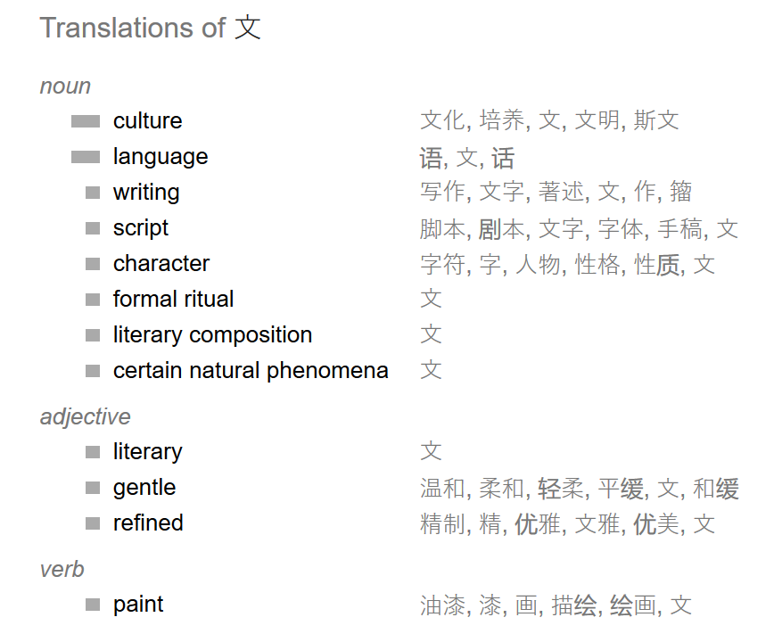
Chinese words may consist of one or more than one syllable. Two-syllable words predominate in Mandarin Chinese. The meaning of a two-syllable word is usually the combination of the meanings of each character/syllable. However, it is not easy to make a good assumption of the character’s meaning when you do not know the meaning of the word. Try to guess the meaning of 文身 after you have learned that 身 means “body”. Your answer is?
On the other hand, because Chinese words are built by blocks of characters/syllables, learning Chinese vocabulary can be significantly logical and efficient. For instance, by knowing 车means “vehicle,” people likely can guess that the meanings of the following words in Chinese are names of vehicles, but people will not have a clue to the words in the other column if they don’t know English.
Chinese | English
汽车 | car
火车 | train
出租车 | taxi
公交车 | bus
卡车 | truck

https://translate.google.com/#zh-CN/en/%E6%96%87

